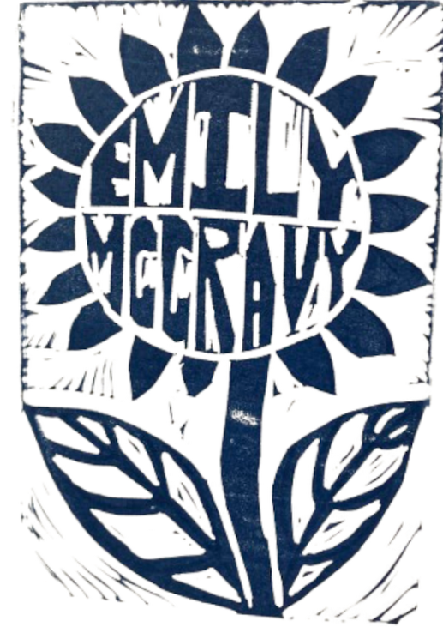
Magic Mind Journal Prompts
Wouldn't it be fun to….
What do I need to know today?
What would the most prosperous fun-loving empowered version of me do today?
Thank you for…..
I really appreciate it…
Thing I would do if I had all the money in the world and time or responsibility didn't exist is…
If I could hear my guides, what would they be telling me right now?
What do I want myself to know today
What would be good for me to know In This Moment?
What would truly feed my creative spirit today?
What's one thing that I love to do as a kid that I haven't done in a really long time?
What is the greatest expression of me today?
What do I need to hear today?
What makes my heart sing?
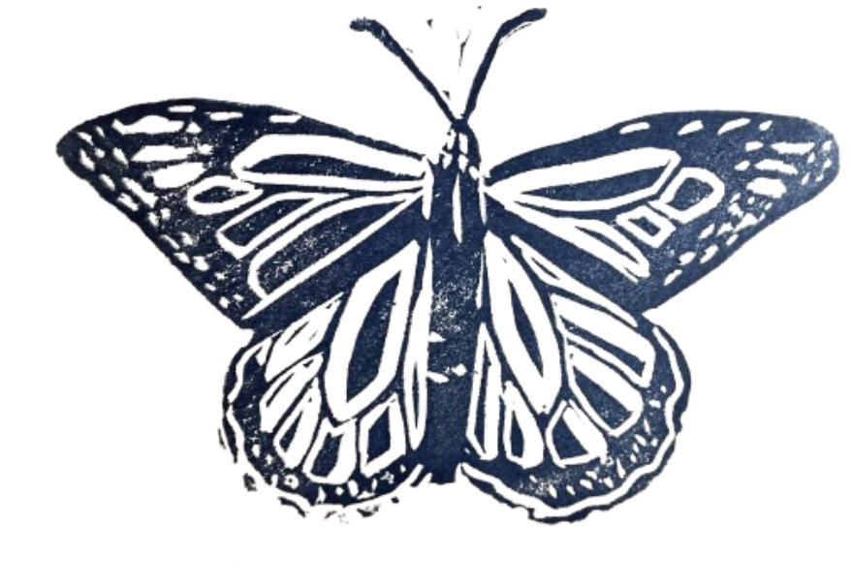
Dear, infinite intelligence, what are your intentions for me today?
I asked the benevolent ancestors to be with me now, as I receive my intention for the day:
What would I do if today were my birthday?
What is important for me to focus on today?
If my heart could speak to me, what would it say?
Benevolent intelligence, please advise me about _______..
What are some things I can do today to align with _______? (Example, wealth, happiness, abundance)
What is one thing that you did lately that you really loved?
You are loveable even when.. (thing happens that you are struggling with) ex
I am loveable even when I am late to an appointment.
I am so excited that…
A part of me wants…
A part of me doesn’t want…
A part of me feels…
If “I don’t know” wasn’t an option I would know…
I am thrilled to learn more about…
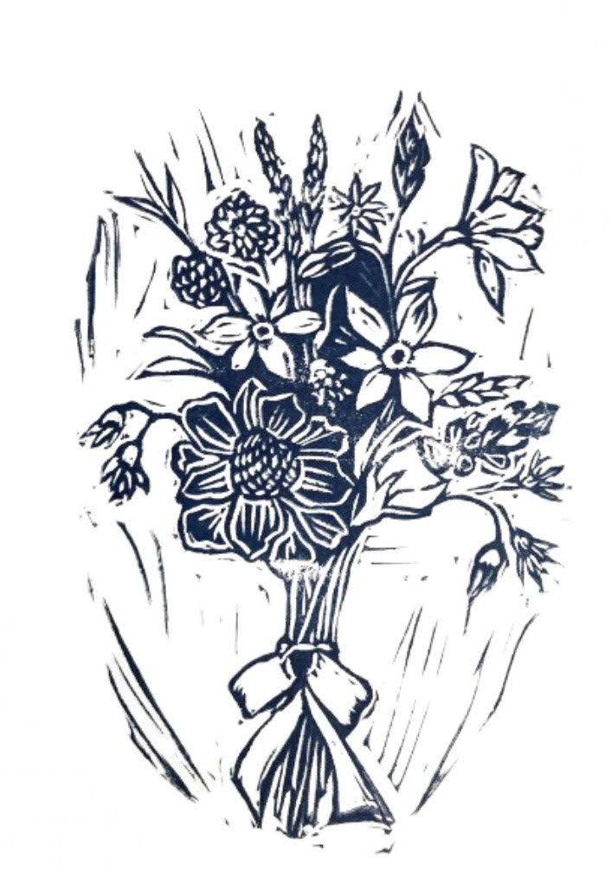
Write our beliefs that no longer serve you and literally cross them out, rewrite them and then write in all caps DONE. You can do this about obsessing about situations as well. Write out a few sentences about the situation then cross it out, reframe it on the way you want to experience it and write DONE in all caps.
Example: OLD belief: “this is too good to be true. The other shoe is going to drop. Scratch that out and write DONE. REPLACED with: life gets better and better every day.
the better it gets, the better it gets. I can have more love, beauty, money,time, light connection, travel, beautiful experiences, and more community.

Beloved ancestors, is there something you would like to share with me today?

